**HIGH LEVEL DOCUMENT**

**CUSTOMER RELATION SHIP MANAGEMENT**

**Table of contents**

**Lead Management**

1.1 Adding and Updating Leads

1.2 Sales Representative Dashboard

**Sales Process**

2.1 Deal Negotiation and Closure

2.2 Opportunity Tracking

**User Management**

3.1 Admin Controls

3.2 Permission Adjustments

**Customer Support**

4.1 Ticketing System

4.2 Integration with CRM

**Marketing Automation**

5.1 Zapier Integration

**Technology Stack**

6.1 Backend

6.2 Frontend

**SYSTEM ARCHITECTURE**

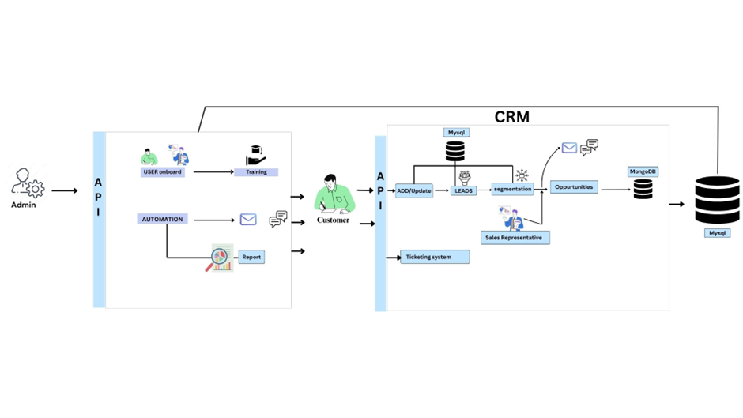

**Features of Customer Relationship Management**

1. **Lead Management**

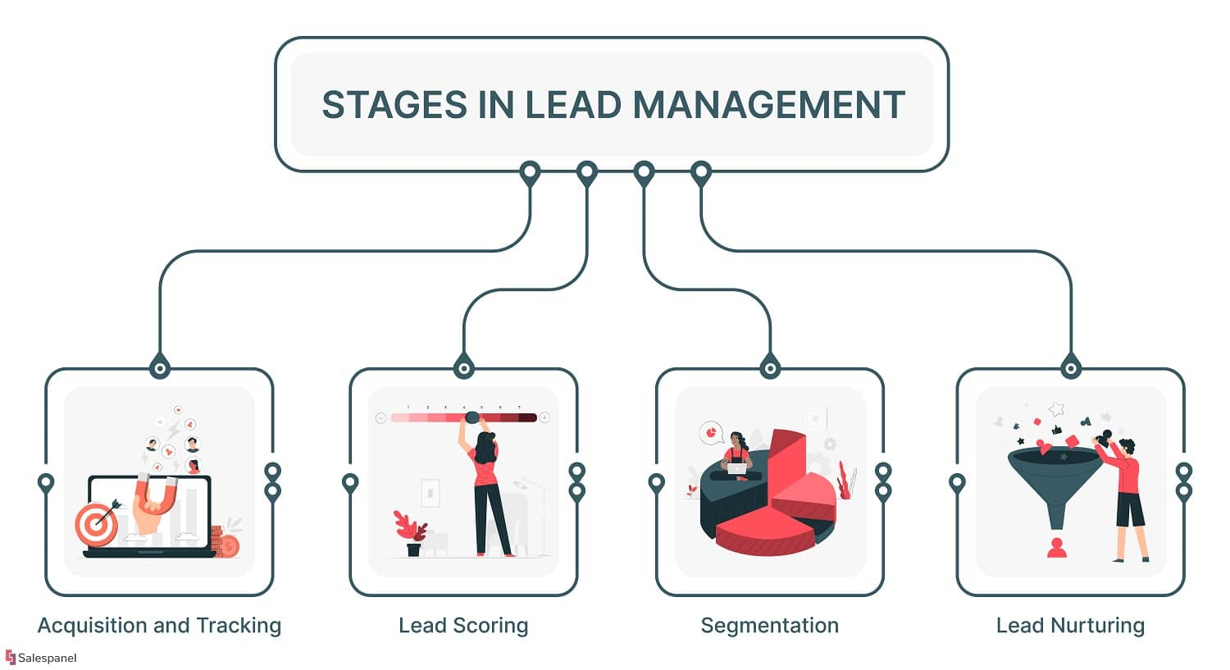

**1.1 Adding and Updating Leads**

**1.1.1 User Interface for Lead Entry:**

**Description:** The system provides an intuitive and user-friendly interface for users to input and update lead information.

**Features:**

**Customizable Forms:** Users can access forms tailored to capture specific lead details, ensuring flexibility**.**

**Validation Rules:** Built-in validation rules prevent errors and ensure data accuracy during lead entry.

**Rich Data Types:** Support for various data types, including text, numeric, date, and file uploads, for comprehensive lead information.

**1.1.2 Lead Information Storage:**

**Description:** Once entered, lead information is stored in a centralized database, facilitating easy retrieval and management**.**

**Features:**

**Database Structure**: Utilizes a database like MongoDB, to organize and store lead data efficiently.

**Data Encryption:** Implements encryption protocols to ensure the security of sensitive lead information.

**Indexing:** Optimizes database indexing for quick search and retrieval of lead records.

**1.1.3 Lead Categorization and Tagging:**

**Description:** Leads are categorized and tagged to streamline organization and enhance search capabilities**.**

**Features:**

**Categories:** Leads can be classified into predefined categories (e.g., industry, source) for better segmentation.

**Tags:** Allows users to tag leads with custom labels for quick identification and filtering.

**1.1.4 Automated Lead Capture:**

**Description:** Integrates with external sources or applications to automate lead capture and minimize manual data entry.

**Features:**

**API Integration:** Utilizes APIs to connect with lead generation platforms, website forms, or other systems**.**

**Data Parsing:** Parses incoming data to extract relevant lead information and populate the CRM**.**

* 1. **Sales Representative Dashboard**

**1.2.1 Visual Representation of Leads:**

**Description:** Sales representatives are equipped with a dynamic dashboard providing an overview of their lead pipeline.

**Key Features:**

**Pipeline Visualization:** Utilizes graphical representations to display leads in various stages of the sales funnel.

**Color-Coding:** Implements color-coded indicators to highlight lead status and priority.

**1.2.2 Lead Filtering and Sorting:**

**Description:** Sales representatives can efficiently manage leads by applying filters and sorting options on the dashboard**.**

**Features:**

**Custom Filters**: Allows users to create custom filters based on lead attributes, source, or other criteria.

**Sorting Options:** Provides multiple sorting options, such as alphabetical or by lead value.

**1.2.3 Real-Time Lead Updates:**

**Description**: Enables sales representatives to receive real-time updates on lead activities, ensuring timely and informed decision-making.

**Features:**

**Activity Feed:** Displays a chronological activity feed for each lead, documenting interactions and changes**.**

**Notifications:** Sends instant notifications(email) to sales representatives for critical lead updates or status changes.

**1.2.4 Collaboration and Communication Tools:**

**Description:** Facilitates seamless communication and collaboration between sales representatives and within the team**.**

**Features:**

**In-App Messaging**: Integrates a messaging system within the dashboard (WhatsApp Api) for quick team communication.

**Task Assignments:** Allows sales representatives to assign tasks related to specific leads directly from the dashboard**.**

**2. Sales Process**

**Description:** The CRM system equips sales representatives with robust tools to facilitate effective negotiations with leads.

**Features:**

**Document Sharing:** Enables the sharing of proposals, contracts, and other documents directly within the CRM.

**Version Control:** Tracks document revisions and ensures that the latest version is always available during negotiations.

**2.1.1 Real-Time Communication:**

**Description:** Promotes real-time communication between sales representatives and leads during the negotiation process.

**Features:**

**Chat**: Integrates a chat feature for instant communication, addressing questions and concerns promptly.

**Notification System:** Sends alerts for new messages or negotiation updates to keep all parties informed.

**2.1.2 Pricing and Discount Management:**

**Description**: Streamlines the management of pricing and discounts during the negotiation phase.

**Features:**

**Pricing Configuration:** Allows sales representatives to configure and present pricing options based on lead requirements.

**Discount Approval Workflow:** Implements a workflow for discount approval, ensuring adherence to company policies.

**2.1.3 Deal Approval Workflow:**

**Description:** Establishes a structured workflow for the approval of deals, involving relevant stakeholders.

**Features:**

**Customizable Approval Levels:** Defines multiple approval levels based on deal value and complexity.

**Automated Notifications**: Notifies approvers at each level with detailed deal information for informed decision-making.

**2.2 Opportunity Tracking**

**2.2.1 Opportunity Creation and Management:**

**Description:**  Sales representatives can efficiently create and manage opportunities based on successful deal negotiations.

**Features:**

Automatic Opportunity Generation: Generates opportunities automatically upon deal closure, eliminating manual data entry.

**2.2.2 Forecasting and Reporting:**

**Description:** Enables accurate forecasting and reporting on potential revenue based on the status of opportunities.

**2.2.3 Activity Logging:**

**Description:** Logs and tracks all activities related to each opportunity, providing a comprehensive history.

**Features:**

**Communication History:** Records emails, calls, meetings, and other interactions associated with a particular opportunity.

**User Activity Log**: Maintains a log of user actions and updates made to the opportunity.

**2.2.4 Automated Follow-ups:**

**Description:** Automates follow-up tasks and reminders to ensure timely actions on opportunities.

**Features:**

**Scheduled Reminders:** Allows users to schedule follow-up tasks and set reminders for important dates.

**Email Automation:** Automates follow-up emails based on predefined triggers or events in the opportunity lifecycle.

**3. User Management**

**3.1 Admin Controls**

**3.1.1 Role Assignment:**

**Description**: The Admin module provides tools for assigning specific roles to users, defining their responsibilities within the CRM system.

**Features:**

**Role Templates**: Offers predefined role templates to expedite the role assignment process.

**Custom Roles:** Allows the creation of custom roles tailored to match the organizational structure.

**3.1.2 Permission Configuration:**

**Description:** The Admin has the authority to configure permissions for each role, determining access levels and functionalities.

**Features:**

**Granular Permissions:** Enables fine-grained control over CRM features, limiting or granting access based on role requirements.

**3.1.3 User Onboarding:**

**Description:** Facilitates the onboarding process for new users by providing necessary credentials and access privileges.

**Features:**

**User Creation Workflow**: Guides Admin through a workflow to set up new user accounts efficiently.

**3.1.4 Role-Based Dashboards:**

**Description:** Customizes dashboards based on user roles to present relevant information aligned with their responsibilities.

**Features:**

**Dashboard Templates:** Offers templates for different roles, tailoring information and widgets to specific job functions.

**4. Customer Support**

**4.1 Ticketing System**

**Description:** Users and sales representatives can create tickets within the CRM to report issues, seek assistance, or request information.

**Features:**

**Custom Ticket Forms:** Provides customizable ticket forms with fields relevant to different types of inquiries.

**Attachment Support:** Allows users to attach files or screenshots to provide additional context.

**4.2. Integration with CRM**

**4.2.1 Unified Customer Interaction:**

* **Description:** Seamlessly integrates the ticketing system with the CRM to provide a unified view of customer interactions.
* **Features:**
  + Single Customer Profile: Associates tickets with the respective customer profiles, offering a holistic view of customer interactions.
  + Linked Activities: Links ticket-related activities (e.g., emails, calls) directly to the customer's CRM record.

**5. Marketing Automation**

**5.1 Zapier Integration**

**5.1.1 Workflow Automation:**

* **Description:** Integrates with Zapier to automate workflows and streamline processes within the CRM.
* **Features:**
  + Trigger-Action Automation: Utilizes Zapier triggers to initiate actions within the CRM based on predefined events.
  + Multi-Step Zaps: Creates workflows with multiple steps to automate intricate business processes.

**Social Media Engagement Automation:**

**Description:** Streamlines social media engagement by automating actions based on CRM data through Zapier.

**Features:**

**Social Media Posting:** Automates social media posts based on CRM updates, such as new product launches or achievements.

**Lead Engagement Tracking:** Captures social media interactions and updates lead profiles in the CRM.

**6. Technology Stack**

* 1. **Backend**

**Java and Spring Boot:**

* Description: Java, a robust and versatile programming language, is employed for the backend development. Spring Boot, a framework built on top of Java, facilitates rapid development of scalable and efficient applications.
* Features:
  + **Object-Oriented Design:** Leverages the object-oriented paradigm of Java for modular and maintainable code.
  + **Spring Boot Auto-Configuration**: Simplifies setup and configuration, accelerating development.

**Database**

MongoDB:

* **Description:** A combination of MongoDB is utilized for data storage, catering to both structured and unstructured data requirements.
* **Features:**
  + **MongoDB (Unstructured Data):** Accommodates flexible and scalable storage of unstructured data, offering versatility for various CRM needs.

**6.2 Frontend**

**AngularJS:**

* **Description**: AngularJS is employed for frontend development, providing a dynamic and responsive user interface.
* **Features:**
  + **Two-Way Data Binding:** Enhances real-time updates and synchronization between the UI and backend data.
  + **Modular Architecture:** Adopts a modular approach for organized and maintainable frontend code.

**Testing**

**Junit:**

* **Description:** Junit is the chosen testing framework for comprehensive testing, ensuring code quality and reliability.
* **Features:**
  + **Unit Testing:** Enables the testing of individual units or components to ensure they function as intended.
  + **Test Suites:** Facilitates the creation of test suites for organized and systematic testing.

**Integration Testing:**

* **Description:** Integration testing is conducted to validate the interaction between different modules and components.
* **Features:**
  + **Ensures Seamless Integration**: Verifies that various parts of the system work together seamlessly.
  + **Detects Interface Issues:** Identifies and resolves issues related to the interfaces between different modules.

**Automated Testing with Selenium:**

* **Description:** Selenium is integrated for automated testing of web applications, ensuring consistent functionality across different browsers.
* **Features:**
  + Cross-Browser Testing: Automates testing across various browsers to guarantee a consistent user experience.
  + Regression Testing: Facilitates automated regression testing to catch and address potential issues after updates.

**Load and Performance Testing with JMeter:**

* **Description:** JMeter is employed for load and performance testing, evaluating the system's ability to handle concurrent users and assess its responsiveness.

**Features:**

* + **Scalability Assessment:** Evaluates the system's scalability by simulating various load conditions.
  + **Performance Metrics:** Provides detailed performance metrics to identify and address bottlenecks.

**Continuous Testing with Jenkins:**

* **Description:** Jenkins is integrated into the CI/CD pipeline for continuous testing, ensuring that code changes do not introduce defects.
* **Features:**
  + **Automated Test Execution:** Triggers automated tests with each code commit to validate changes.
  + **Test Result Reporting**: Generates comprehensive reports on test results, aiding in quick issue identification.

**THANK YOU**